MARKER’S REPORT

Name of Marker : Munish Kumar

Course Code/Title : ANL252

Semester : Jan 2023

PART I

Overall Performance of Students in the Examination:

Briefly Describe:

Majority of students passed. I am quite heartened by their performance. Excluding the no shows, the passing rate was >90%. Of 37 students graded, the 3 failure were due to incomplete papers. Shown below is the Mean grade of 65.2%.

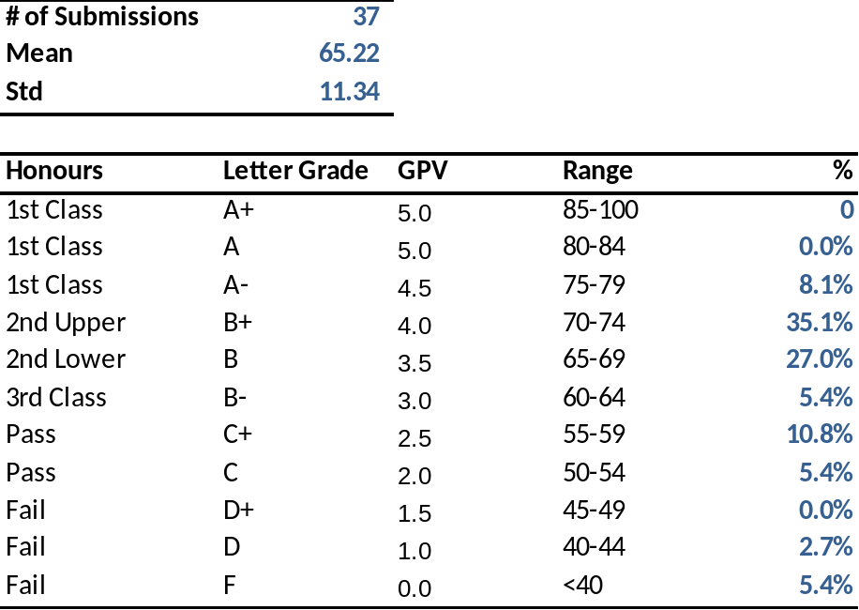

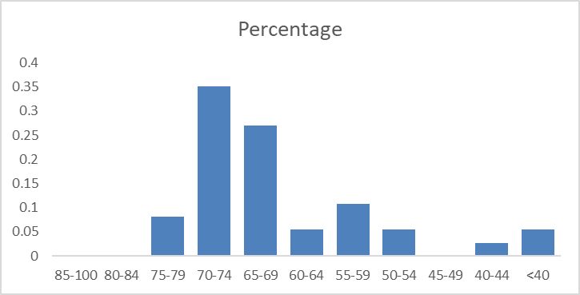

Strengths and Weaknesses of Students in Examination:

Students can be broadly categorized into 2 groups. For students that generally understood the programming goals and methods, their shortcoming was actually poor explanation or data understanding. In other words, what does the data actually mean? For students who had a strong grasp of the theory, they wrote very elegant, efficient codes, and took to programming like ducks to water.

Poorer students struggled with conceptual basics. I think it would help if future modules incorporated some element of programming design, “pseudo code” writing, or analysis of logic. Another thing I noted student struggling with was the idea of “data cleaning” was data “wrangling”.

What I was most pleased about however was that EVERY student did what was demonstrated in class – things like documenting the code, having lots of comments, being very deliberate in variable names and choices.

PART II

Overall performance of Question 1 to 6.

Please see the Bloom Learning outcomes score below

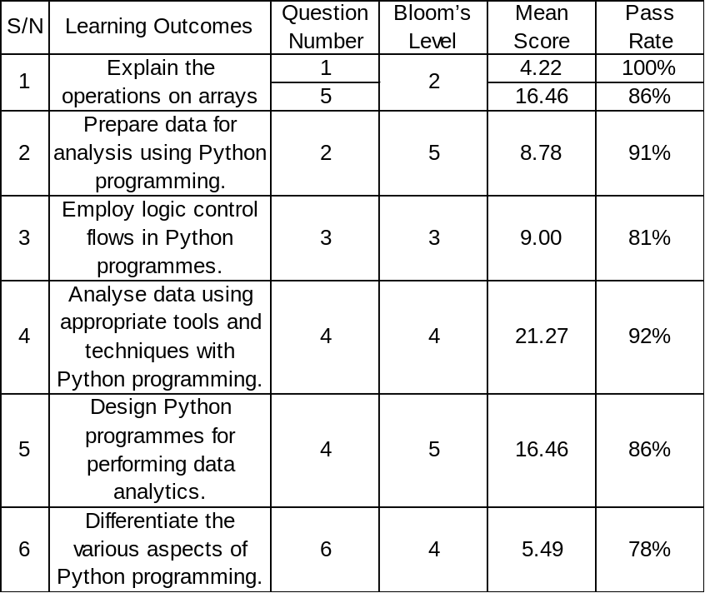

Strengths and weaknesses of students with regard to Question
1 to 6

Most students did reasonably well when it came to showing their skills with python, refer to statistics below

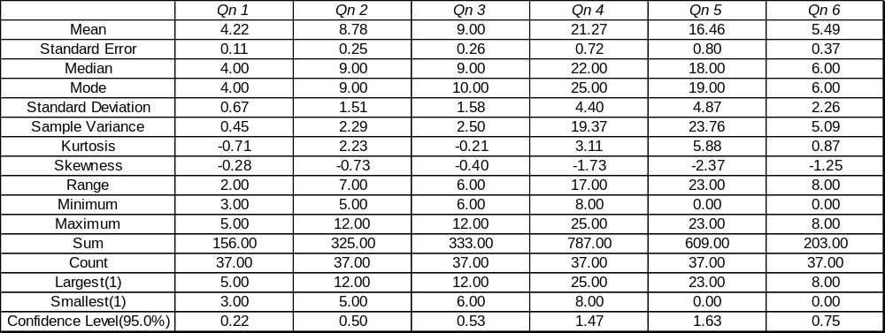

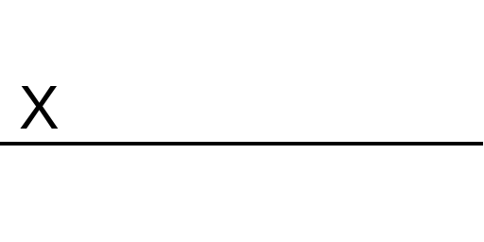 |  | Mar 2023
Marker’s Signature |  | Date

